- DG型多级泵

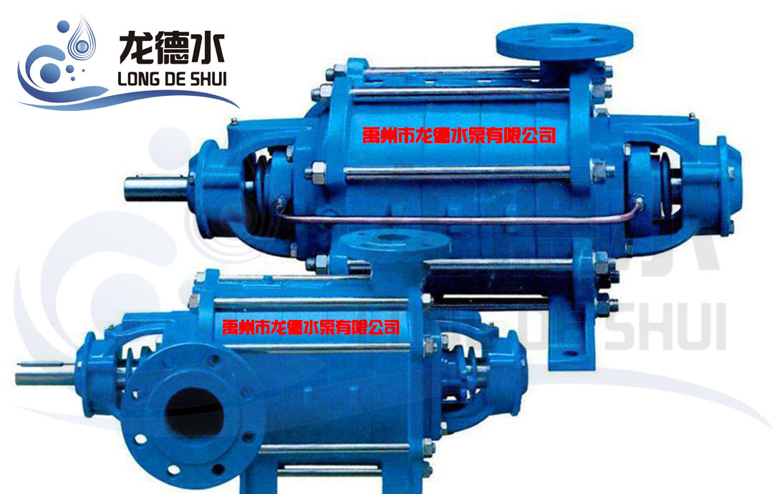
型号意义
例：D(DG)155-67x9
- D----多级离心水泵
- DG---多级锅炉给水泵
- 155--流量（m³/h)
- 67---单级扬程（米）
- 9----级数

性能参数
型号 | 转速  r/min | 流量 |  | 扬程  m | 效率  % | 功率（kw） |  | 必须汽蚀余量（m）
 |  | m³/h | L/S |  |  | 轴功率 | 电机功率
D.DG6-25x3 | 2950 | 6.3 | 1.75 | 75 | 45 | 2.86 | 5.5 | 2.0
D.DG6-25x4 | 2950 | 6.3 | 1.75 | 100 | 45 | 3.81 | 7.5 | 2.0
D.DG6-25x5 | 2950 | 6.3 | 1.75 | 125 | 45 | 4.77 | 7.5 | 2.0
D.DG6-25x6 | 2950 | 6.3 | 1.75 | 150 | 45 | 5.72 | 11 | 2.0
D.DG6-25x7 | 2950 | 6.3 | 1.75 | 175 | 45 | 6.67 | 11 | 2.0
D.DG6-25x8 | 2950 | 6.3 | 1.75 | 200 | 45 | 7.63 | 15 | 2.0
D.DG6-25x9 | 2950 | 6.3 | 1.75 | 225 | 45 | 8.52 | 15 | 2.0
D.DG6-25x10 | 2950 | 6.3 | 1.75 | 250 | 45 | 9.53 | 18.5 | 2.0
D.DG6-25x11 | 2950 | 6.3 | 1.75 | 275 | 45 | 10.5 | 18.5 | 2.0
D.DG6-25x12 | 2950 | 6.3 | 1.75 | 300 | 45 | 11.4 | 18.5 | 2.0
D.DG12-25x3 | 2950 | 12.5 | 3.47 | 75 | 54 | 4.73 | 7.5 | 2.0
D.DG12-25x4 | 2950 | 12.5 | 3.47 | 100 | 54 | 6.30 | 11 | 2.0
D.DG12-25x5 | 2950 | 12.5 | 3.47 | 125 | 54 | 7.88 | 11 | 2.0
D.DG12-25x6 | 2950 | 12.5 | 3.47 | 150 | 54 | 9.46 | 15 | 2.0
D.DG12-25x7 | 2950 | 12.5 | 3.47 | 175 | 54 | 11.0 | 15 | 2.0
D.DG12-25x8 | 2950 | 12.5 | 3.47 | 200 | 54 | 12.51 | 18.5 | 2.0
D.DG12-25x9 | 2950 | 12.5 | 3.47 | 225 | 54 | 14.18 | 18.5 | 2.0
D.DG12-25x10 | 2950 | 12.5 | 3.47 | 250 | 54 | 15.76 | 22 | 2.0
D.DG12-25x11 | 2950 | 12.5 | 3.47 | 275 | 54 | 17.34 | 22 | 2.0
D.DG12-25x12 | 2950 | 12.5 | 3.47 | 300 | 54 | 18.9 | 30 | 2.0
D.DG25-30x3 | 2950 | 25 | 6.94 | 90 | 62 | 9.88 | 15 | 2.2
D.DG25-30x4 | 2950 | 25 | 6.94 | 120 | 62 | 13.1 | 18.5 | 2.2
D.DG25-30x5 | 2950 | 25 | 6.94 | 150 | 62 | 16.47 | 22 | 2.2
D.DG25-30x6 | 2950 | 25 | 6.94 | 180 | 62 | 19.77 | 30 | 2.2
D.DG25-30x7 | 2950 | 25 | 6.94 | 210 | 62 | 23.1 | 30 | 2.2
D.DG25-30x8 | 2950 | 25 | 6.94 | 240 | 62 | 26.4 | 37 | 2.2
D.DG25-30x9 | 2950 | 25 | 6.94 | 270 | 62 | 29.65 | 37 | 2.2
D.DG25-30x10 | 2950 | 25 | 6.94 | 300 | 62 | 32.9 | 45 | 2.2
D.DG46-30x3 | 2950 | 46 | 12.8 | 90 | 70 | 16.11 | 22 | 3.0
D.DG46-30x4 | 2950 | 46 | 12.8 | 120 | 70 | 21.48 | 30 | 3.0
D.DG46-30x5 | 2950 | 46 | 12.8 | 150 | 70 | 26.85 | 37 | 3.0
D.DG46-30x6 | 2950 | 46 | 12.8 | 180 | 70 | 32.21 | 37 | 3.0
D.DG46-30x7 | 2950 | 46 | 12.8 | 210 | 70 | 37.58 | 45 | 3.0
D.DG46-30x8 | 2950 | 46 | 12.8 | 240 | 70 | 42.95 | 55 | 3.0
D.DG46-30x9 | 2950 | 46 | 12.8 | 270 | 70 | 48.32 | 55 | 3.0
D.DG46-30x10 | 2950 | 46 | 12.8 | 300 | 70 | 53.69 | 75 | 3.0
D.DG46-50x3 | 2950 | 46 | 12.8 | 150 | 63 | 29.83 | 37 | 2.8
D.DG46-50x4 | 2950 | 46 | 12.8 | 200 | 63 | 39.77 | 45 | 2.8
D.DG46-50x5 | 2950 | 46 | 12.8 | 250 | 63 | 49.71 | 55 | 2.8
D.DG46-50x6 | 2950 | 46 | 12.8 | 300 | 63 | 59.65 | 75 | 2.8
D.DG46-50x7 | 2950 | 46 | 12.8 | 350 | 63 | 69.6 | 90 | 2.8
D.DG46-50x8 | 2950 | 46 | 12.8 | 400 | 63 | 79.54 | 90 | 2.8
D.DG46-50x9 | 2950 | 46 | 12.8 | 450 | 63 | 89.48 | 110 | 2.8
D.DG46-50x10 | 2950 | 46 | 12.8 | 500 | 63 | 99.42 | 110 | 2.8
D.DG46-50x11 | 2950 | 46 | 12.8 | 550 | 63 | 109.36 | 132 | 2.8
D.DG46-50x12 | 2950 | 46 | 12.8 | 600 | 63 | 119.3 | 132 | 2.8
型号 | 转速  r/min | 流量 |  | 扬程  m | 效率  % | 功率（kw） |  | 必须汽蚀余量（m）
 |  | m³/h | L/S |  |  | 轴功率 | 电机功率
DG85-45x2 | 2950 | 85 | 23.6 | 90 | 72 | 28.94 | 37 | 4.2
DG85-45x3 | 2950 | 85 | 23.6 | 135 | 72 | 43.4 | 55 | 4.2
DG85-45x4 | 2950 | 85 | 23.6 | 180 | 72 | 57.87 | 75 | 4.2
DG85-45x5 | 2950 | 85 | 23.6 | 225 | 72 | 72.34 | 90 | 4.2
DG85-45x6 | 2950 | 85 | 23.6 | 270 | 72 | 86.81 | 110 | 4.2
DG85-45x7 | 2950 | 85 | 23.6 | 315 | 72 | 101.3 | 132 | 4.2
DG85-45x8 | 2950 | 85 | 23.6 | 360 | 72 | 115.7 | 132 | 4.2
DG85-45x9 | 2950 | 85 | 23.6 | 405 | 72 | 130.2 | 160 | 4.2
DG155-30x2 | 2950 | 155 | 43 | 60 | 77 | 32.84 | 55 | 3.2
DG155-30x3 | 2950 | 155 | 43 | 60 | 77 | 49.26 | 75 | 3.2
DG155-30x4 | 2950 | 155 | 43 | 120 | 77 | 65.68 | 90 | 3.2
DG155-30x5 | 2950 | 155 | 43 | 150 | 77 | 82.10 | 110 | 3.2
DG155-30x6 | 2950 | 155 | 43 | 180 | 77 | 98.52 | 132 | 3.2
DG155-30x7 | 2950 | 155 | 43 | 210 | 77 | 114.97 | 160 | 3.2
DG155-30x8 | 2950 | 155 | 43 | 240 | 77 | 131.36 | 180 | 3.2
DG155-30x9 | 2950 | 155 | 43 | 270 | 77 | 147.78 | 180 | 3.2
DG155-30x10 | 2950 | 155 | 43 | 300 | 77 | 164.20 | 225 | 3.2
D.DG155-67x3 | 2950 | 155 | 43 | 201 | 74 | 114.7 | 132 | 5.0
D.DG155-67x4 | 2950 | 155 | 43 | 268 | 74 | 152.6 | 185 | 5.0
D.DG155-67x5 | 2950 | 155 | 43 | 335 | 74 | 191.1 | 220 | 5.0
D.DG155-67x6 | 2950 | 155 | 43 | 402 | 74 | 229.3 | 280 | 5.0
D.DG155-67x7 | 2950 | 155 | 43 | 469 | 74 | 267.5 | 350 | 5.0
D.DG155-67x8 | 2950 | 155 | 43 | 536 | 74 | 305.7 | 350 | 5.0
D.DG155-67x9 | 2950 | 155 | 43 | 603 | 74 | 344 | 440 | 5.0
DG280-43x2 | 2950 | 280 | 77.8 | 86 | 77 | 85.17 | 110 | 4.0
DG280-43x3 | 2950 | 280 | 77.8 | 129 | 77 | 127.7 | 150 | 4.0
DG280-43x4 | 2950 | 280 | 77.8 | 172 | 77 | 170.3 | 230 | 4.0
DG280-43x5 | 2950 | 280 | 77.8 | 215 | 77 | 212.9 | 300 | 4.0
DG280-43x6 | 2950 | 280 | 77.8 | 258 | 77 | 255.5 | 300 | 4.0
DG280-43x7 | 2950 | 280 | 77.8 | 301 | 77 | 298.1 | 350 | 4.0
DG280-43x8 | 2950 | 280 | 77.8 | 344 | 77 | 304.7 | 410 | 4.0
DG280-43x9 | 2950 | 280 | 77.8 | 387 | 77 | 383.2 | 430 | 4.0
DG280-65x6 | 2950 | 280 | 77.8 | 390 | 73 | 407.4 | 500 | 3.0
DG280-65x7 | 2950 | 280 | 77.8 | 455 | 73 | 475.3 | 680 | 3.0
DG280-65x8 | 2950 | 280 | 77.8 | 520 | 73 | 543.2 | 680 | 3.0
DG280-65x9 | 2950 | 280 | 77.8 | 585 | 73 | 611.1 | 850 | 3.0
DG280-65x10 | 2950 | 280 | 77.8 | 650 | 73 | 579 | 850 | 3.0
DG450-60x3 | 2950 | 450 | 125 | 180 | 79 | 299.2 | 360 | 4.2
DG450-60x4 | 2950 | 450 | 125 | 240 | 79 | 372.3 | 500 | 4.2
DG450-60x5 | 2950 | 450 | 125 | 300 | 79 | 465.4 | 680 | 4.2
DG450-60x6 | 2950 | 450 | 125 | 360 | 79 | 558.2 | 680 | 4.2
DG450-60x7 | 2950 | 450 | 125 | 420 | 79 | 651.5 | 850 | 4.2
DG450-60x8 | 2950 | 450 | 125 | 480 | 79 | 744.6 | 850 | 4.2
DG450-60x9 | 2950 | 450 | 125 | 540 | 79 | 837.7 | 1050 | 4.2
DG450-60x10 | 2950 | 450 | 125 | 600 | 79 | 930.8 | 1050 | 4.2

